Answers HW3

1. Vector Clocks are able to decide if events are causally dependent on another. We can not do this with Lamport timestamps, because Lamport timestamps enforce a total order for all events. In other words, Vector clocks satisfy the strong consistency condition, but Lamport timestamps do not.

2. Clock C2 depends causally from C1 if C1 != C2 (elementwise comparison) and all values in C1 are smaller or equal to the corresponding values in C2.

3. The clock tick happens before we send, because this way if P1 sends its clock to P2, after P2 receives the clock they both have the same value fort he clock of P1. If P1 would update its clock after sending it, the clock that P2 receives is out-of-date from the beginning.

4. 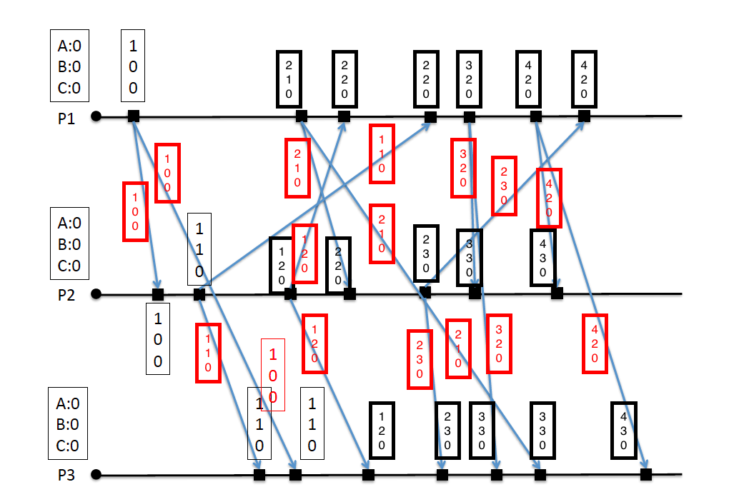

5. The problem of using Vector clocks with a dynamic number of interacting processes is solved in this paper.